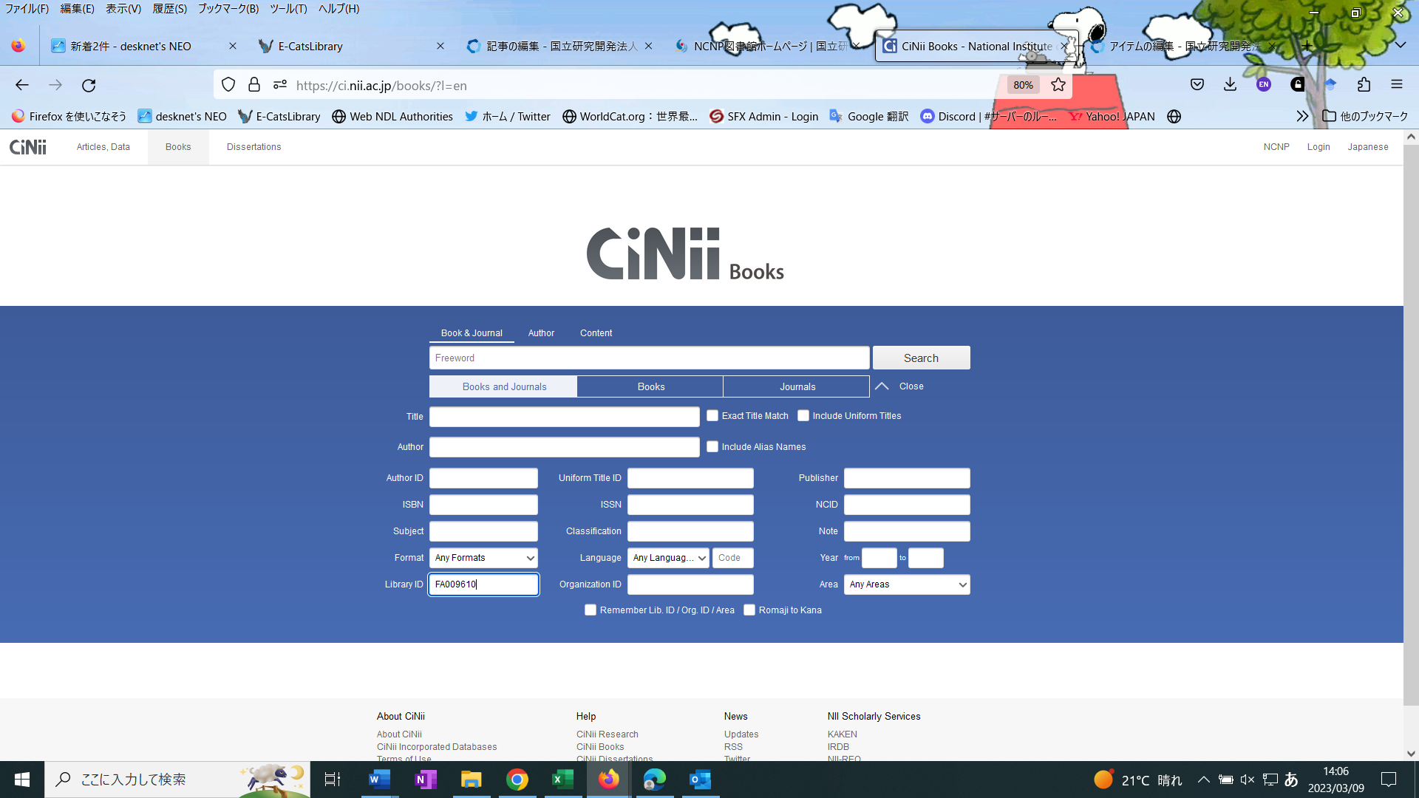

Enter “FA009610” in Library ID field